**Teacher Registration Instructions**

**2025-2026**

**Creating a Teacher Account**

* Teachers need to register before their students can begin to register. Follow the steps below to begin registration.
* Go to the contest URL: <http://registration.nhd.org/>. **Then pick your contest.**
* Click **Create Account** in the toolbar, then select **Teacher** from the drop-down menu.
* Insert your first name, last name, and email address. Click the checkbox next **to I am Not a Robot.** Then, click the **Save & Continue** button.
* Complete the Teacher’s Personal Information section. Then, click the **Save & Continue** button.
* Complete the School section. Then, click the **Save & Continue** button.
* Complete the Additional Information section. Then, click the **Save & Continue** button.
* Complete the Teacher’s Permissions and Waivers section. Then, click the **Save & Continue** button.
* Registration is complete. Your username will appear on this screen. Record your system username and password.
* You will receive a registration confirmation email from zFairs. Using a school email address may block the registration confirmation email or mark it as spam.

**Logging into Teacher Account (After Registering)**

* Go to the contest URL: <http://registration.nhd.org/>
* Click **Login** in the top right corner.
* Insert your username and password.
  + If you forgot your username and/or password, click the blue **Help** hyperlink and follow the prompts to reset.

**Logging Out of Teacher Account**

* Click your name in the top right corner.
* Select **Logout** from the drop-down menu.

**Editing Teacher Account Information**

* After logging in to your teacher account, click your name in the top right corner.
* Select **My Profile** from the drop-down menu to edit your personal information before registration ends.
* Select **Change Password** to change the password for your account.

**Checking Your Students’ Registration Progress**

* After logging in to your teacher account, click **My Students** in the top toolbar.
* This page lists each of your students. Click on a name to bring up a pop-up menu. You can **Edit/View Participant** profiles, change **Passwords** or **Usernames**, **Link/Unlink** Projects, and **Email Participants**. This is optional and can only be done before contest registration closes.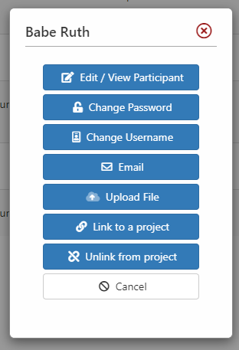

**Generating an Invoice and/or Paying for Students**

* After logging in to your teacher account, click **Store** in the top toolbar.
* Select the **Students** tab. Here, you will see a list of students linked to your account.
* Select the students that you want on your invoice. Then, click **Add Selected Fees to Cart**.
* Once added to the cart, click the **Checkout and Pay** tab. This will prompt you to either pay online or generate an invoice.
  + If you select **Pay Online**, you will insert your credit/debit card information and proceed with payment.
  + If you select **Generate an Invoice**, this will take you to an invoice page. You can either send the link to the invoice to your administrator or print the page and give it to your administrator.